Moors Youth Football Club
Respect Code of Conduct

The purpose of this document is to explain what is expected from the players and parents and what you can expect from the club.

Name of Child Age Group:

YOUTH PLAYERS

When playing football, I will:
- Always do my best, even if we are losing or the other team is stronger
- Play fairly – I won’t cheat, complain or waste time
- Never be rude to my team mates, the other team, the referee, spectators or my coach/Team manager
- Do what the referee tells me
- Shake hands with the other team and referee at the end of the game
- Listen to my Coach/Team manager and respect what he/she says
- Talk to someone I trust, for example my parents or the club welfare officer if I’m unhappy about anything at my club.

If I break the code, the following action can be taken:
- Speak to me and warn me to improve my behaviour
- Speak to my Mum, Dad or Carer about my behaviour
- Stop me from training
- Stop me from playing in the next match or a number of matches.
- Not allow me to register next season
- Serve a suspension
- Pay a fine
- Leave the Club
- My club could also be formally penalised
- Have my registration taken away by the league

PARENTS / CARERS / SPECTATORS

I/ We Will:
- Remain outside the field of play and behind the Designated Spectator Area/Marking (where provided)
- Never engage in, or tolerate, offensive, insulting or abusive language or behaviour
- Always respect the match officials decisions
- Applaud effort and good play as well as success

In addition, when attending youth games I will:
- Remember that children play for FUN
- Let the coaches do their job and not confuse the players by telling them what to do
- Encourage the players to respect the opposition and the match officials
- Never criticise a player for making a mistake – mistakes are part of learning

If I break the code, the following action may be taken:
- A Verbal warning from my club coach/team manager, the league official or the referee.
- Being asked to leave the match venue by the club
- Being asked by the club not to attend future games
- If a parent, my child not being allowed to register next season
- My club should be formally penalised
- Being asked to leave the club

CLUB / COACH / TEAM MANAGERS / CLUB OFFICIALS

On and off the field, I will:
- Show respect to others involved in the game including match officials, opposition players, coaches, managers, officials and spectators
- Adhere to the laws and spirit of the game
- Promote Fair Play and high standards of behaviour
- Always respect the match officials decision
- Never enter the field of play without the referee’s permission
- Never engage in public criticism of the match officials
- Never engage in, or tolerate, offensive, insulting or abusive language or behaviour

When working with players I will:
- Place the well being safety and enjoyment of each player above everything, including winning
- Explain exactly what I expect of players and what they can expect of me
- Ensure all parents/carers of all players under the age of 18 understand these expectations
- Never engage in or tolerate any form of bullying
- Develop mutual trust and respect with every player to build their self- esteem
- Encourage each player to accept responsibility for their own behaviour and performance
- Ensure all activities I organise are appropriate for the players ability level, age and maturity
- Co-operate fully with others in football (e.g. officials, doctors, physiotherapists, welfare officers) for each players best interests

I understand that if I do not follow the code, any/all of the following actions may be taken by my club, county FA or The FA:

I may be:
- Required to meet with the club, league, or county welfare officer
- Required to meet with the Club committee
- Monitored by another club coach
- Required to attend an FA education course
- Suspended by the club from attending matches
- Suspended or fined by the County FA
- Required to leave or be sacked by the Club

In addition:

My FACA (FA Coaches Association) membership may be withdrawn

I understand that breaches of the code may result in action being taken by my County FA and / or The FA, which are outlined in this document.

Parents/Carer’s Signature | Player’s Signature | Club Officials Signature
Print Name | Print Name | Print Name
Date | Date | Date
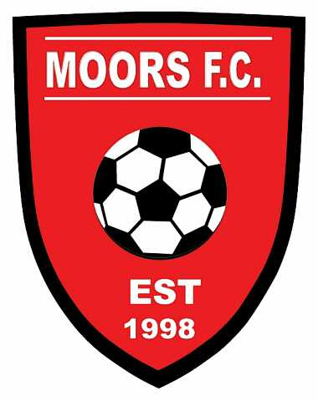M

